**Competitor Analysis Report**

**BMW company :-**

**Bayerische Motoren Werke AG**, commonly abbreviated to **BMW** (German pronunciation is a German multinational manufacturer of [luxury vehicles](https://en.wikipedia.org/wiki/Luxury_vehicle) and [motorcycles](https://en.wikipedia.org/wiki/Motorcycle) headquartered in [Munich](https://en.wikipedia.org/wiki/Munich), [Bavaria](https://en.wikipedia.org/wiki/Bavaria), Germany. The company was founded in 1916 as a manufacturer of [aircraft engines](https://en.wikipedia.org/wiki/Aircraft_engine), which it produced from 1917 to 1918 and again from 1933 to 1945 creating engines for aircraft that were used in the [Second World War](https://en.wikipedia.org/wiki/World_War_II).

Digital marketing strategy :-

|  |  |  |  |
| --- | --- | --- | --- |
| Name | Instagram followers:- | Facebook followers:- | Youtube followers:- |
| BMW | 39.2m | 20m | 1.51m |

BMW maintains active profiles on social media platform like Facebook, Instagram, and Youtube to engage with the members.

`Social Media Strategy of BMW

Regardless of how big the company is, the social media strategy of the global car manufacturer’s is no different than other brand. BMW uses social platform such as LinkedIn, Instagram, Facebook, YouTube or even TikTok to showcase its latest products, engage with customers, and promote its brand values. One of the key elements of BMW’s social media strategy is visual storytelling. The company highlights its design and engineering prowess by using high-quality images and videos to show off its products in use. This helps to create an emotional connection with its target audience and reinforce its brand image as a luxury car manufacturer.

Another aspect of BMW’s social media strategy is its focus on customer engagement. The brand regularly responds to comments and messages from customer, and encourages them to share their own stories and experiences with BMW vehicles. This helps to build a sense of community around the brand and foster long term loyalty.

In fact, BMW invites people to use the #BMWRepost hashtag for a chance to be featured on the company’s Instagram account which has almost 35M followers.

In addition, BMW has also experimented with newer social media features and platforms, such as Instagram stories and TikTok. For example, the company has created short videos showcasing its latest models and design features on these platform, which has helped to reach younger audiences and stay relevant on a rapidly evolving social media landscape.

Branding Strategy of BMW

The branding strategy of this premium car manufacturer focuses on providing high-quality products that highlight innovation, excellent engineering, and cutting-edge technology. Here are a few points that BMW has in its marketing mix:

1. Premium Pricing

BMW positions itself as a premium brand manufacturing premium cars which is reflected in its pricing strategy. Its cars are prices higher than those of its competitors, but the brand’s reputation for quality and engineering justifies the premium.

2. Performance-oriented

The company is known for producing high-performance vehicles, which reinforces the brand’s image as a leader in engineering and innovation. BMW’s focus on performance is also reflected in its advertising.

Here’s the ad for the first-ever BMW M5 CS Sedan, an excellent example of how the company showcases the performance of its German miracle car:

Advertising Strategy of BMW

As for its advertising strategy, BMW has traditionally focused on creating memorable campaigns that emphasize the brand’s premium positioning and performance-oriented focus.

The brand’s key elements for its advertising strategy are:

1. Emotional Appeal

BMW’s advertising often seeks to connect with consumers on an emotional level. This includes emphasizing the joy of driving, the thrill of high-performance vehicles, and the sense of freedom and independence that comes with owning a BMW. Below, find the ad where the brand used its creative storytelling strategies to engage with its audience:

2. Product-focused

BMW’s advertising campaigns often focus on the features and benefits of specific models. This includes highlighting performance features, technological innovations, and design elements that make BMW cars stand out from the competition.

BMW iX1 – Electrify Your Dreams

3. Consistent messaging

Just like its branding strategy, BMW’s advertising is characterized by consistent messaging that reinforces the brand’s premium positioning and performance focus. The brand has consistently communicated its brand identity through all its marketing efforts. This includes a consistent visual identity, brand voice and messaging that emphasizes BMW’s engineering excellence and innovative spirit

“BMW is fortunate-we don’t have too much of a dilemma as to what we’re going to call our cars.” – Jim McDowell, Vice President of Marketing at BMW

The fact that BMW marketing strategy concentrates on high-end segments on a global scale and consistently defines premium brand identification renders success. Trendsetting and attractive product range deliberately targets affluent customers and demonstrates the success of the automaker’s global marketing strategy. If you want to build a strong marketing strategy for your company just like BMW, make sure to check out automotive marketing agencies to find the suitable agency to partner with.

Responding sensitively to the unique values and purchasing behavior enabled BMW to transcend intended performance. So to specifically present, below we have listed brilliant examples of BMW commercials released in recent years and their underlying marketing tactics behind them.

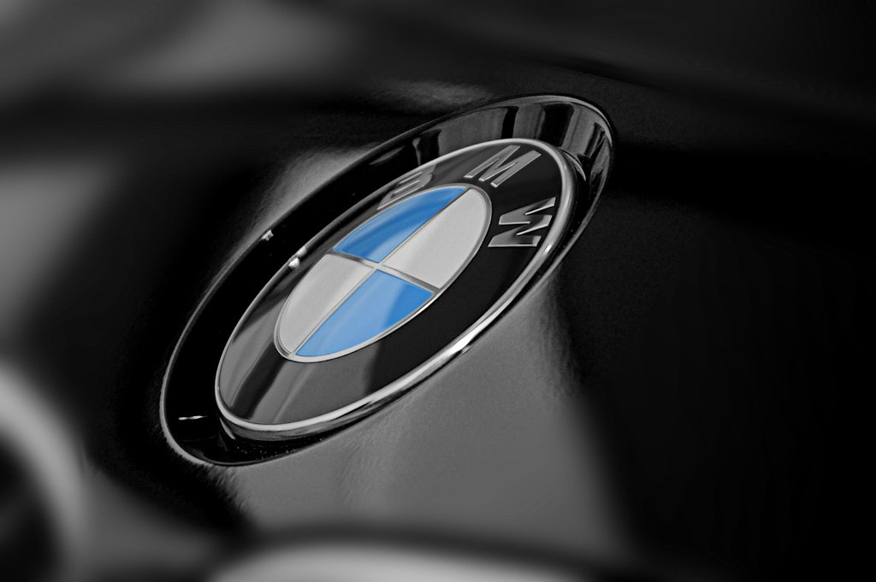

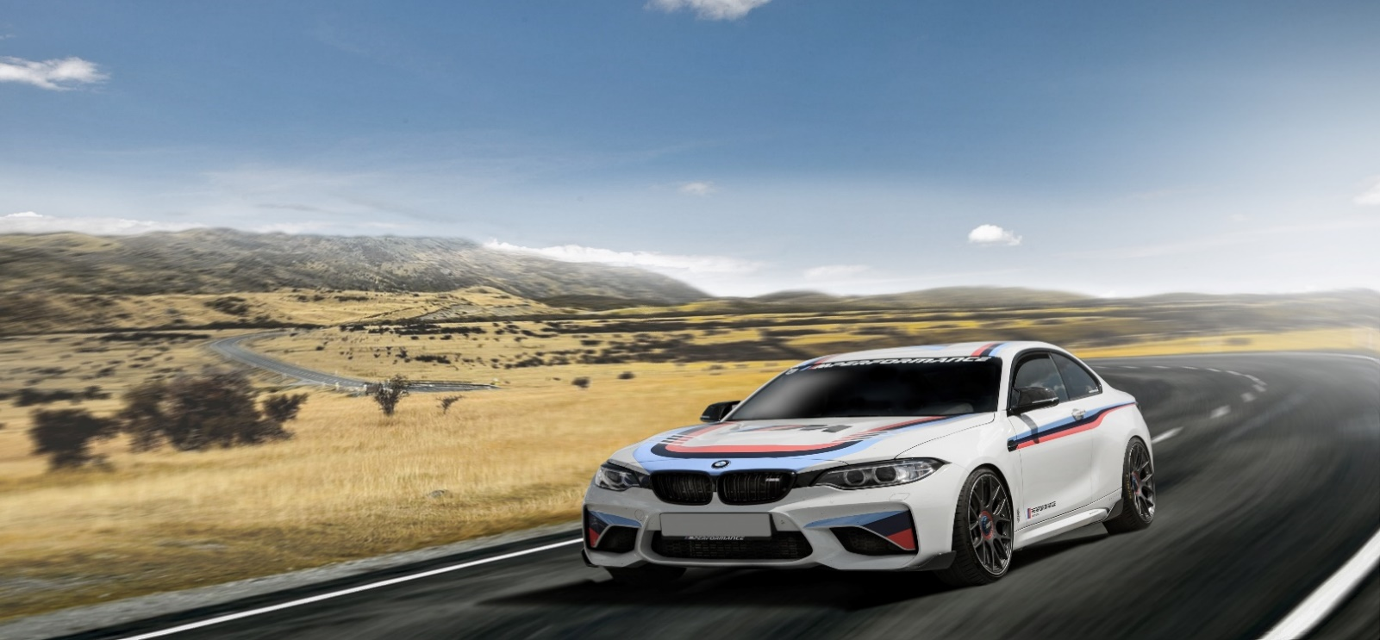Website:-

(https://www.bmw.com/)

Competitor :-

* Mercedes-Benz

Mercedes-Benz has a rich history dating back to the late 19th century. The company traces its roots to the invention of the first gasoline-powered car by Karl Benz in 1886, often regarded as the birth of the automobile. Mercedes-Benz, as we know it today, emerged from the merger of Benz & Cie. and Daimler-Motoren-Gesellschaft in 1926. Since then, Mercedes-Benz has grown into a globally recognized brand synonymous with luxury, innovation, and automotive excellence. Their commitment to craftsmanship and technological advancement has made them a leader in the automotive industry, with a reputation for producing cars that blend performance with sophistication.

Digital marketing strategy:-

Mercedes-Benz employs a comprehensive digital marketing strategy to reach and engage with its target audience effectively. Here are some key elements typically included in their digital marketing approach:

1. Website Optimization: Mercedes-Benz ensures its website is user-friendly, visually appealing, and informative. It provides detailed information about their vehicles, features, and services, allowing customers to research and explore options easily.

2. Social Media Presence: Mercedes-Benz maintains active profiles on major social media platforms such as Facebook, Instagram, Twitter, and LinkedIn. They use these channels to share product updates, promotional campaigns, customer stories, and engaging content related to their brand values and lifestyle.

3. Content Marketing: The company creates high-quality content such as articles, videos, and infographics that appeal to their target audience. This content often focuses on automotive trends, technological innovations, safety features, and lifestyle topics associated with luxury and performance.

4.Search Engine Optimization (SEO): Mercedes-Benz optimizes its online content and website structure to improve search engine rankings. This ensures that potential customers can easily find their products and services when searching for related keywords.

5. Email Marketing: Mercedes-Benz utilizes email campaigns to nurture leads, inform customers about new models, promotions, and events, and maintain ongoing engagement with their audience. Personalization and segmentation are often used to tailor content to specific customer interests.

6.Digital Advertising: The company invests in targeted digital advertising campaigns across various channels, including search engines, social media platforms, and automotive websites. These campaigns aim to increase brand visibility, drive traffic to their website, and generate leads.

7.User Experience (UX) Optimization: Mercedes-Benz focuses on delivering a seamless and engaging online experience across all digital touchpoints. This includes mobile optimization, fast loading times, intuitive navigation, and responsive customer support.

8. Data Analytics and Customer Insights: Mercedes-Benz uses data analytics tools to track website traffic, user behavior, and campaign performance. This data helps them make informed decisions, refine their marketing strategies, and improve customer engagement and satisfaction.

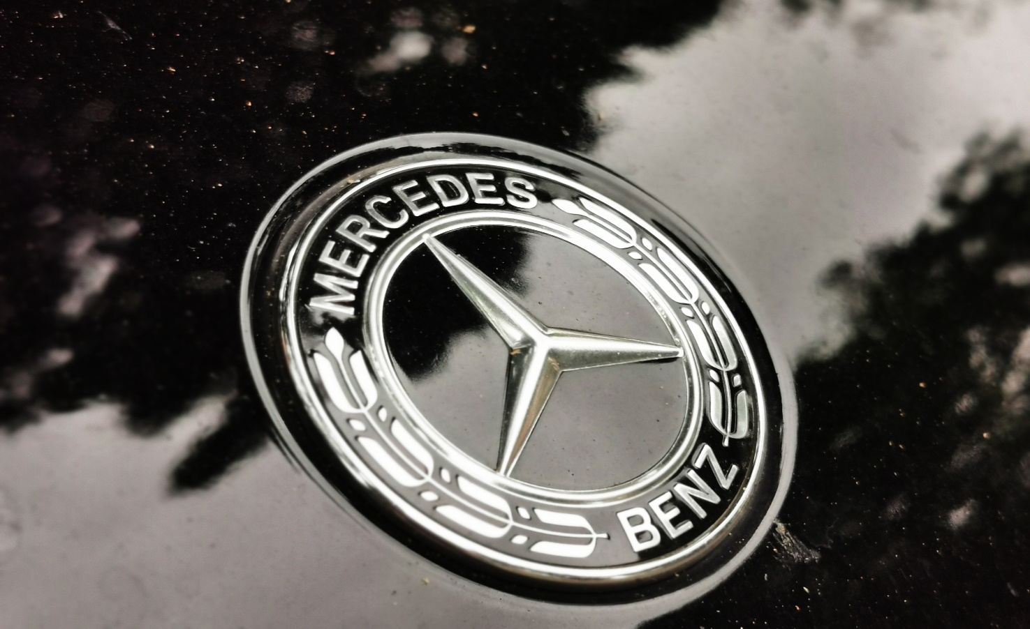Overall, Mercedes-Benz's digital marketing strategy is designed to enhance brand awareness, build customer loyalty, and drive sales by leveraging digital channels and technologies effectively.



Website:-

(https://www.mercedes-benz.com/)

* Audi :-

Audi is a prominent German automobile manufacturer known for its luxury vehicles, engineering excellence, and technological innovation. Founded in 1909 by August Horch, Audi's origins trace back to the early days of the automotive industry in Germany. The company's name "Audi" is derived from the Latin translation of its founder's surname, which means "hear" in German—a nod to the founder's previous automotive ventures.

In its early years, Audi quickly gained a reputation for producing high-quality cars distinguished by their performance and reliability. The brand became a part of Auto Union AG in 1932.

Digital marketing Strategy:-

Audi employs a sophisticated digital marketing strategy aimed at enhancing brand awareness, engaging with its target audience, and driving sales. Here are key elements typically included in Audi's digital marketing approach:

Website Optimization: Audi ensures its official website is user-friendly, visually appealing, and informative. It provides comprehensive information about their vehicle lineup, features, technology, and services. The website is optimized for mobile devices to cater to a broader audience.

Social Media Presence: Audi maintains active profiles on major social these channels to share engaging content, including product launches, behind-the-scenes footage, customer testimonials, and lifestyle content that aligns with their brand image.

Content Marketing: Audi creates compelling content such as articles, videos, and infographics that resonate with their target audience. Content often focuses on automotive technology, safety features, design innovations, and brand heritage, aiming to educate and entertain users while reinforcing Audi's brand values.

Search Engine Optimization (SEO): Audi optimizes its online content and website structure to improve search engine rankings. This helps potential customers easily find information about Audi vehicles, promotions, and dealership locations when searching online.

Email Marketing: Audi uses personalized email campaigns to nurture leads, inform customers about new models, special offers, and events. Email segmentation and automation techniques are often employed to tailor content based on customer preferences and behavior.

Digital Advertising: Audi invests in targeted digital advertising campaigns across various channels, including search engines, social media platforms, automotive websites, and display networks. These campaigns aim to increase brand visibility, drive traffic to their website, and generate leads and sales.

Virtual Reality (VR) and Augmented Reality (AR): Audi explores immersive technologies such as VR and AR to enhance customer experiences. Virtual showrooms, interactive vehicle configurators, and AR apps allow customers to visualize and personalize their Audi vehicles before making a purchase decision.

Data Analytics and Customer Insights: Audi utilizes advanced analytics tools to gather data on website traffic, user behavior, campaign performance, and customer interactions. These insights help Audi make data-driven decisions to optimize marketing strategies, improve customer engagement, and enhance the overall digital experience.

Overall, Audi's digital marketing strategy is characterized by innovation, creativity, and a customer-centric approach. By leveraging digital channels and technologies effectively, Audi aims to strengthen brand loyalty, drive sales growth, and maintain its position as a leader in the luxury automotive market.

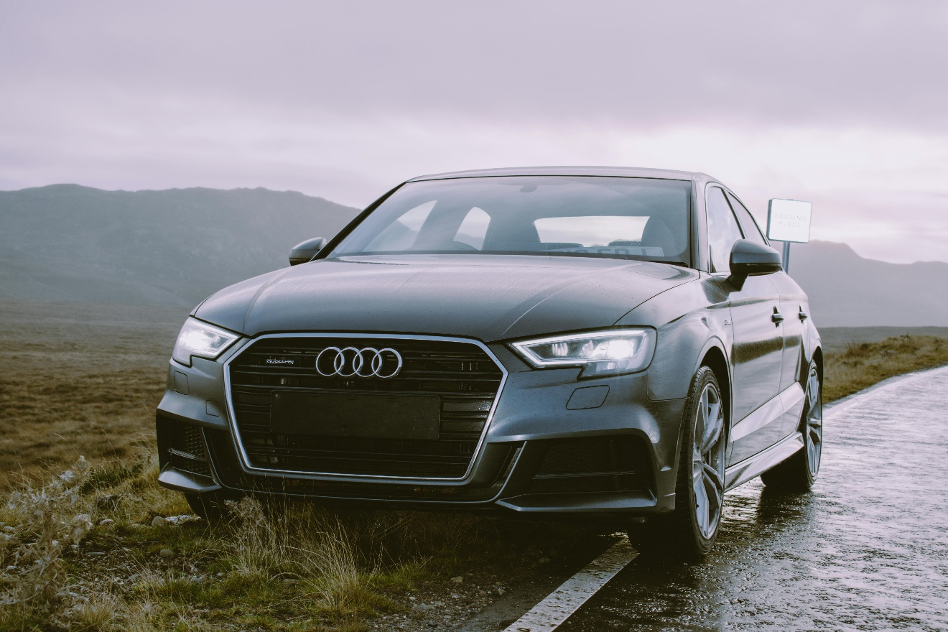

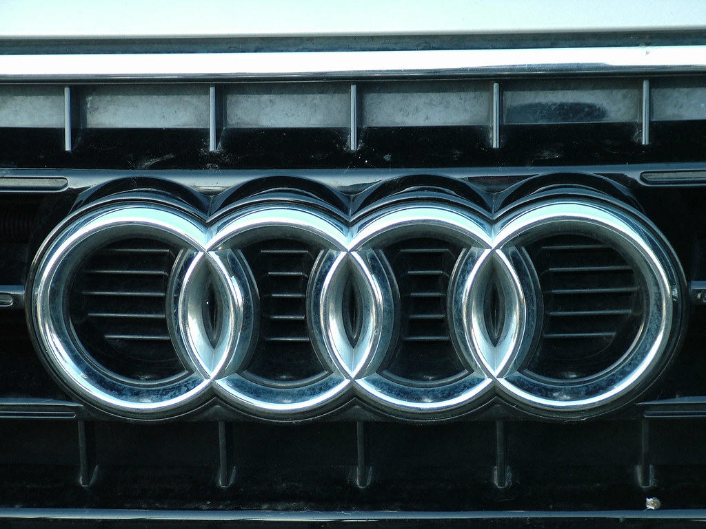

[This Photo](http://flickr.com/photos/kenjonbro/3090575292) by Unknown Author is licensed under [CC BY-NC](https://creativecommons.org/licenses/by-nc/3.0/)

Website:-

(https://www.audi.com/)

* Cadillac CT4:-

Cadillac is an iconic American luxury automobile brand that has been synonymous with prestige, innovation, and quality since its inception. Founded in 1902 by Henry Leland, Cadillac quickly established itself as a pioneer in automotive engineering and luxury craftsmanship.

Early History:Cadillac was named after the French explorer Antoine Laumet de La Mothe, sieur de Cadillac, who founded Detroit in 1701. The brand was acquired by General Motors (GM) in 1909, positioning it within one of the largest automotive corporations in the world.

Luxury:Throughout its history, Cadillac has been known for its luxury vehicles, catering to discerning customers who seek both comfort and performance. Cadillac has consistently aimed to combine advanced technology with opulent interiors and elegant designs.

Digital marketing strategy:-

Cadillac, as a luxury automotive brand, employs a comprehensive digital marketing strategy aimed at enhancing brand perception, driving sales, and engaging with its target audience. Here are some key elements that might be part of Cadillac's digital marketing strategy:

1.Website Optimization: Cadillac ensures its website is not only visually appealing but also user-friendly and optimized for both desktop and mobile devices. It provides a seamless browsing experience and integrates features like vehicle configurators, dealer locators, and online booking tools.

2.Content Marketing: Cadillac creates and distributes high-quality content that resonates with its audience. This includes articles, blog posts, videos, and interactive content that highlight the brand's heritage, technological innovations, and lifestyle appeal.

3.Social Media Presence: Cadillac maintains active profiles on major social media platforms such as Facebook, Instagram, Twitter, and LinkedIn. Each platform is used strategically to showcase new models, promote brand events, share customer stories, and engage with followers through contests, polls, and interactive posts.

4.Influencer Partnerships: To reach a broader audience and leverage social proof, Cadillac collaborates with influencers and celebrities who align with its brand values. These influencers may feature Cadillac vehicles in their content or endorse the brand in their social media posts.

5.Search Engine Optimization (SEO): Cadillac invests in SEO to ensure its website ranks well in search engine results pages (SERPs) for relevant keywords. This helps drive organic traffic to its website and increases visibility among potential customers.

6.Paid Advertising: Cadillac uses targeted digital advertising campaigns across various platforms, including PPC (Pay-Per-Click) ads on search engines and social media ads. These campaigns are designed to increase brand awareness, drive traffic to the website, and generate leads.

7.Email Marketing: Cadillac utilizes email marketing campaigns to nurture leads, promote special offers, announce new vehicle launches, and keep customers informed about the latest updates and developments.

8.Customer Relationship Management (CRM): Cadillac employs CRM systems to manage customer data effectively. This allows them to personalize marketing communications, tailor offers based on customer preferences, and provide exceptional customer service.

9.Virtual Reality (VR) and Augmented Reality (AR): As part of its innovative approach, Cadillac may use VR and AR technologies to provide virtual test drives, showcase vehicle features in an interactive manner, and create immersive brand experiences.

10.Analytics and Performance Tracking: Cadillac continuously monitors the performance of its digital marketing efforts using analytics tools. This helps them measure the effectiveness of campaigns, identify areas for improvement, and make data-driven decisions to optimize their strategies.

Overall, Cadillac's digital marketing strategy is likely a blend of cutting-edge technology, compelling content, targeted advertising, and personalized customer engagement to maintain its position as a leader in the luxury automotive industry.



Website:-

([www.cadillac.com](http://www.cadillac.com))

Followers chart:-

|  |  |  |  |
| --- | --- | --- | --- |
| Name | Instagram followers:- | Facebook followers:- | Youtube followers:- |
| Bmw | 39.2m | 20m | 1.51m |
| Mercedes | 38.7m | 23m | 1.92m |
| Audi | 4.3m | 3.4m | 290k |
| Cadillac | 3.1m | 3.8m | 203k |